**Decision making practicals:**

**If statement**

var1 = 100

if var1:

print "1 - Got a true expression value"

print var1

var2 = 0

if var2:

print "2 - Got a true expression value"

print var2

print "Good bye!

**If else statement**

var1 = 100

if var1:

print "1 - Got a true expression value"

print var1

else:

print "1 - Got a false expression value"

print var1

var2 = 0

if var2:

print "2 - Got a true expression value"

print var2

else:

print "2 - Got a false expression value"

print var2

print "Good bye!"

**nested if/elif**

var = 100

if var < 200:

print "Expression value is less than 200"

if var == 150:

print "Which is 150"

elif var == 100:

print "Which is 100"

elif var == 50:

print "Which is 50"

elif var < 50:

print "Expression value is less than 50"

else:

print "Could not find true expression"

print "Good bye!"

Example 1 : Program to check whether a person is eligible to vote or not.

### Example 2: Program to check whether a number is even or not.

### Example 3: Program to print the largest of the three numbers.

**Nested if**

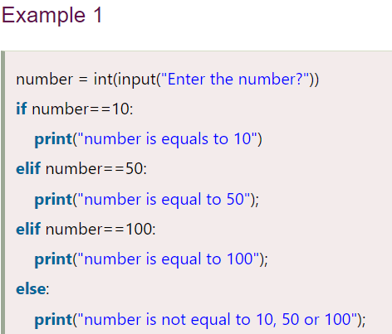

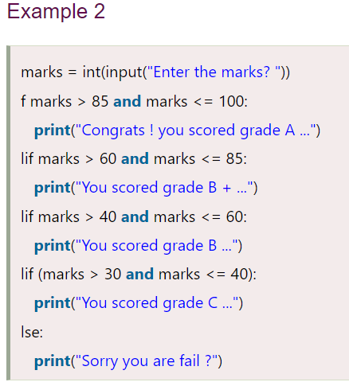

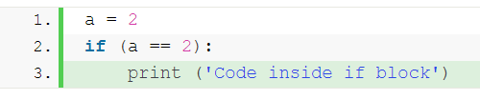

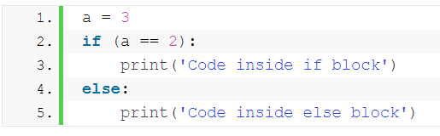

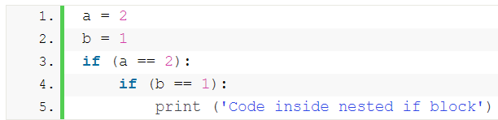

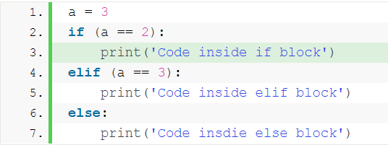

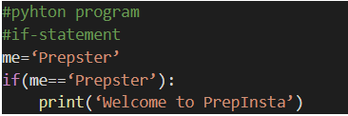

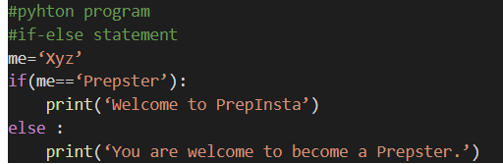

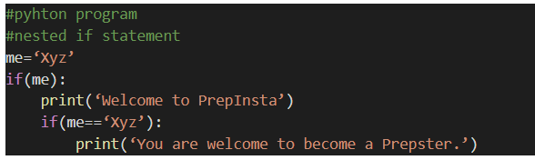

1.Write a program for if statement

2.Write a program and check if x is greater than y and print using if else statement

3. .Write a program for nested if.